Forget the Ones - Examples
Courtney Burch, Gateway Community and Technical College
Solve by elimination
2x + 4y = -1
3x +3y = 1

If we want to eliminate x: If we want to eliminate y:

3(2x + 4y = -1) 3(2x + 4y = -1)
-2(3x + 3y = 1) -4(3x + 3y = 1)

6x + 12y = -3 6x + 12y = -3
-6x - 6y = -2 -12x -12y = -4
6y = -5 -6x = -7
y = -5/6 x = 7/6

Then use back substitution to find the remaining variable.
Only Show Nice Examples Approach
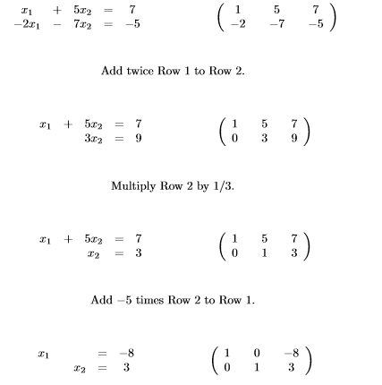
Everything works out nicely with no fractions!
Source: http://www.math.dartmouth.edu/archive/m23s06/public_html/handouts/row_reduction_examples.pdf
Fractions Approach
$$\left[\begin{matrix}2 & 4 & -1 \\ 3 & 3 & 1\end{matrix}\right]$$
Step 1: Multiply Row 1 by 1/2:
$$\left[\begin{matrix}1 & 2 & -1/2 \\ 3 & 3 & 1\end{matrix}\right]$$
Step 2: Replace R2 with -3R1 + R2:
-3R1 -3 -6 3/2
+R2 3 3 1
0 -3 5/2

$$\left[\begin{matrix}1 & 2 & -1/2 \\ 0 & -3 & 5/2\end{matrix}\right]$$
Step 3: Multiply Row 2 by -1/3:
$$\left[\begin{matrix}1 & 2 & -1/2 \\ 0 & 1 & -5/6\end{matrix}\right]$$
Step 4: Replace R1 with R1 + -2R2:
R1 1 2 -1/2
-2R2 0 -2 10/6
1 0 7/6
$$\left[\begin{matrix}1 & 0 & 7/6 \\ 0 & 1 & -5/6\end{matrix}\right]$$

Linear Combination Approach
$$\left[\begin{matrix}2 & 4 & -1 \\ 3 & 3 & 1\end{matrix}\right]$$
Find a linear combination of 2 and 3 that equals 1.
Replace R1 with -R1 + R2.
-R1 -2 -4 1
+R2 3 3 1
1 -1 2 $$\left[\begin{matrix}1 & -1 & 2 \\ 3 & 3 & 1\end{matrix}\right]$$
Step 2: Replace R2 with -3R1 + R2
-3R1 -3 3 -6
+R2 3 3 1
0 6 -5
Find a linear combination of -1 and 6 that equals 1.
$$\left[\begin{matrix}1 & -1 & 2 \\ 0 & 6 & -5\end{matrix}\right]$$
Step 3: Replace R2 with 5R1 + R2
5R1 5 -5 10
+R2 0 6 -5
5 1 5
$$\left[\begin{matrix}1 & -1 & 2 \\ 5 & 1 & 5\end{matrix}\right]$$
But now we’ve lost the 0 we had in column 1 before, so the linear combination approach did not work here. We need a different approach for Step 3.
Step 3 Alternative Option 1: If our linear combination for Step 3 did not work, switch to fraction method and multiply R2 by 1/6
$$\left[\begin{matrix}1 & -1 & 2 \\ 0 & 1 & -5/6\end{matrix}\right]$$
Then continue as in the fractions method.
Step 3 Alternative Option 2: If we cannot come up with a linear combination for Step 3, use whatever number is there to turn the number in Row 1 Column 2 into 0. Replace R1 with 6R1 + R2:
6R1 6 -6 12
+R2 0 6 -5
6 0 7$$\left[\begin{matrix}6 & 0 & 7 \\ 0 & 6 & -5\end{matrix}\right]$$
But now we have lost the 1 we had in the first column! Is that okay, or is it not okay? Why did we do a step to get a one there if we’re just going to undo it?

“Forget the Ones” Method:
$$\left[\begin{matrix}2 & 4 & -1 \\ 3 & 3 & 1\end{matrix}\right]$$
Step 1: Replace R2 with -3R1 + 2R2.
-3R1 -6 -12 3
2R2 6 6 2
0 -6 5 $$\left[\begin{matrix}2 & 4 & -1 \\ 0 & -6 & 5\end{matrix}\right]$$

Step 2: Replace R1 with 3R1 + 2R2:
3R1 6 12 -3
2R2 0 -12 10
6 0 7 $$\left[\begin{matrix}6 & 0 & 7 \\ 0 & -6 & 5\end{matrix}\right]$$

Step 3: Multiply R1 by 1/6 and R2 by -1/6:
$$\left[\begin{matrix}1 & 0 & 7/6 \\ 0 & 1 & 5/6\end{matrix}\right]$$

