KYMATYC

44th Annual Meeting
Historic Boone Tavern
Berea, KY
Friday, February 23rd &
Saturday, February 24th, 2018
All times are local time (eastern time)

A special thanks to the following KYMATYC Sponsors.
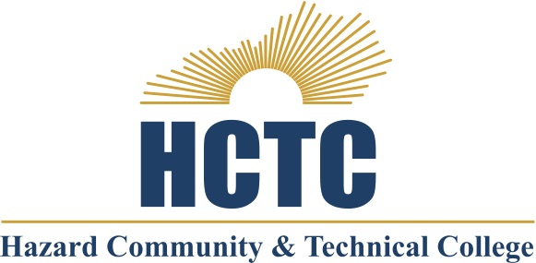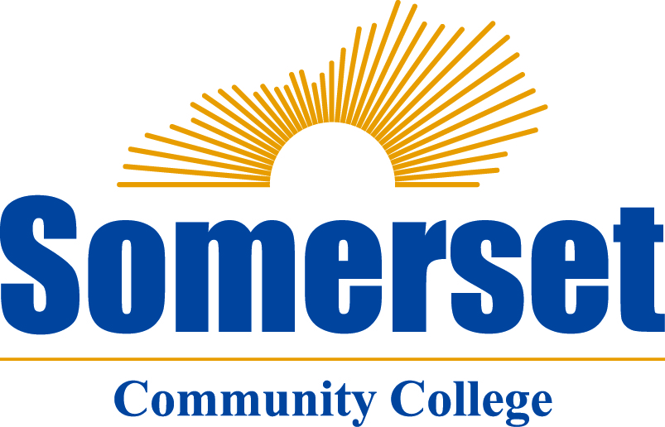

Forty-Fourth Annual Meeting of KYMATYC

Conference Agenda

Friday, February 23th, 2018 All times are local time (eastern time)

12:00 - ?? PM Registration

1:25 - 2:15 Concurrent Session #1

Event Center
Presenter: Tina Ragsdale - WKCTC
Presider: Pat Riley, Hopkinsville Community College
Co-Requisite College Algebra.
Our college has implemented Co-Requisite College Algebra courses using a variety of formats. I will be able to provide data showing the effectiveness of varied techniques such as embedded tutors, instructional techniques and supplemental instruction.

Coyle Gathering Room
Presenter: Scott Taylor– Henderson Community College
Presider: Jeff Herrin, Bluegrass Community and Technical College
Evolution of College Algebra—an Historical Perspective.
College Algebra has been a longstanding tradition in both the KCTCS and throughout Kentucky, but few are aware of its rich history. This will be a fun look at the evolution of college algebra in Kentucky—namely via KCTCS and the University of Kentucky. This session will provide enjoyment and entertainment at some of the historical influences on the evolution of postsecondary Kentucky math. Together, we can all figure out what the f(x) college algebra really is.

Skylight Room
Presenter: Impromptu Room
Presider: Scott McClendon, Somerset Community College
This year’s conference will have a breakout room Friday and Saturday for conversations among colleagues. You can sign up at the registration table for a time when you would like to meet colleagues. This room can be used to discuss a “hot topic” that has come to your attention right before the conference or for subcommittee get-togethers. If you discover a topic that you would like to initiate a conversation about or to continue a discussion that couldn’t be completed in a session, pick a time slot to get together in the Impromptu Room. Check the room sign to see who has signed up and what topic they will be discussing.

2:25 – 3:15 Concurrent Session #2

Event Center
Presenter: Jon Oaks, Macomb Community College – AMATYC Midwest Regional Vice-President
Presider: Brandon Bartley, Jefferson Community and Technical College
Bringing the STATS to K.E.N.T.U.C.K.Y
In this session, the presenter will discuss some of the challenges that might arise when teaching a statistics course that has an intermediate algebra prerequisite. What might a class like this look like compared to other mathematics and statistics courses? That’s right, we’re bring the STATS to K.E.N.T.U.C.K.Y. (Kolmogorov Extrapolation Normality T-test Uniform Categorical Kruskal Yates).

Coyle Gathering Room
Presenter: Pat Riley- Hopkinsville Community College
Presider: Jeff Herrin, Bluegrass Community and Technical College
Wile E. Coyote: Calculus Genius
Using the Wile E. Coyote and Roadrunner cartoons, I’ve created a couple examples which can be used to cover some pesky topics in calculus (MAT 170). It will start with a college algebra quadratic formula example and then lead into equations of lines tangent to a point. The final example will incorporate the idea of critical points and some website software to quickly solve large systems of equations….not normally covered in an intro calculus class. Participants might want to bring a laptop with Excel to get the full effect of the activities.

Skylight Room
Presenter: Impromptu Room
Presider: Scott McClendon, Somerset Community College
This year’s conference will have a breakout room Friday and Saturday for conversations among colleagues. You can sign up at the registration table for a time when you would like to meet colleagues. This room can be used to discuss a “hot topic” that has come to your attention right before the conference or for subcommittee get-togethers. If you discover a topic that you would like to initiate a conversation about or to continue a discussion that couldn’t be completed in a session, pick a time slot to get together in the Impromptu Room. Check the room sign to see who has signed up and what topic they will be discussing.

3:20-3:50 Break Visit Exhibitor’s Tables and enjoy the refreshments sponsored by Pearson

3:55-4:45 Concurrent Session #3

Event Center
Presenter: Jennifer Ackerman and Drew Wilkerson - Jefferson Community and Technical College
Presider: Pat Riley, Hopkinsville Community College
Results from our Math 146 Co-requisite Course Redesign at Jefferson
Come hear about our exciting results from our pilot semester this fall after spending a year researching co-requisite models and re-designing our MAT 146 course as part of our Title III grant. We’ll talk about the general framework for our co-requisite model as well as some of the details about the class projects and activities. We’ll have hard numbers and student survey results to share. Learn about the details of our collaborative effort and how we built this course from the ground up.

Coyle Gathering Room
Presenter: Scott Taylor– Henderson Community College & Jason Taylor – West Kentucky Community and Technical College
Presider: Jeff Herrin, Bluegrass Community and Technical College
Math Pathways—Where are We and Where are We Going?
A brief overview of Math Pathways—the who, what, where, when, and why. This will be part presentation, part Q&A, and part Panel in delivery.

Skylight Room
Presenter: Impromptu Room
Presider: Brandon Bartley, Jefferson Community and Technical College
This year’s conference will have a breakout room Friday and Saturday for conversations among colleagues. You can sign up at the registration table for a time when you would like to meet colleagues. This room can be used to discuss a “hot topic” that has come to your attention right before the conference or for subcommittee get-togethers. If you discover a topic that you would like to initiate a conversation about or to continue a discussion that couldn’t be completed in a session, pick a time slot to get together in the Impromptu Room. Check the room sign to see who has signed up and what topic they will be discussing.

4:45-5:00 KYMATYC WELCOME – Door Prizes in Main Room shortly before Keynote

5:00 – 5:50 Keynote Address

Event Center

Presenters: Jaclyn M. Murawska and Keith A. Nabb
Presider: Scott McClendon – Somerset Community College
The Calculus of Corvettes.
How can we find authentic mathematical tasks that have a low entry point for engagement, yet challenge the problem solver in a multitude of ways? To answer this question, Jackie and Keith will share their insights and stories using a non-routine calculus task with real-life data from a drag racing event. Participants will explore how this task provides flexible learning opportunities through mathematical modeling and data analysis to deepen students’ understanding of mathematics. Hallmarks of a good problem will also be identified to enable us all to recognize similar worthwhile problems to bring to our college classrooms.

Bios:
Jaclyn Murawska is an Assistant Professor of Mathematics and the Coordinator of Mathematics Education at Saint Xavier University in Chicago, Illinois. She specializes in teaching mathematics content and methods to K-12 preservice teachers. Her research focuses on exploring ways to increase teachers’ pedagogical content knowledge in mathematics.
Keith Nabb is an Assistant Professor of Mathematics at the University of Wisconsin-River Falls. He teaches courses in mathematics and mathematics education at UWRF. His interests include nonroutine problems, inquiry-based learning, student questioning, and mathematical knowledge for teaching.

6:00 Dinner
Coyle Gathering/Skylight Room

7:30 Ignite Session
Coyle Gathering/Skylight Room
Presider: Pat Riley, Hopkinsville Community and College
Check out the ignite session. Those who did not want to present a full session but have an idea or issue they wish to share and session presenters have the opportunity to summarize their presentations. They have exactly 5 minutes in a fast paced, whirlwind, idea sharing session. This session will last as long as there are presenters.

8:30 – 10:00 “After Math” Reception
Coyle Gathering/Skylight Room
Come join us for light and lively conversation, food and drinks. Play some games, catch-up with friends, and network with colleagues and vendors.

Saturday, February 24th, 2018

7:00 AM Breakfast Dining Room

8:00 – ?? Registration

8:10 – 9:00 Concurrent Session #4

Event Center
Presenter: Rena Zanakis and Christopher Sears- Maysville Community and Technical College
Presider: Jeff Herrin, Bluegrass Community and Technical College
Problem Solving Skills in the Mathematics Classroom: Beyond Word Problems
When someone thinks about problem solving in a mathematics course, they are usually thinking about solving a classic word problem, often related to trains. However, the mathematics classroom presents opportunities for problem solving that go beyond problem 100 in the homework set. This talk will present the problem-solving skills, mathematical or otherwise, our students should develop through mathematics coursework.

Coyle Gathering Room
Presenter: Dwight P. Smith - Big Sandy Community & Technical College
Presider: Pat Riley, Hopkinsville Community College
The 2017 Total Eclipse Experience
Last year I was privileged to view the Total Solar Eclipse in Calvert City KY. I have a PowerPoint presentation of my experiences to show. In addition, I will explain how the Saros Cycle predicts solar eclipses. The Saros Cycle has been known since Antiquity.

Skylight Room
Presenter: Impromptu Room
Presider: Scott McClendon, Somerset Community College
This year’s conference will have a breakout room Friday and Saturday for conversations among colleagues. You can sign up at the registration table for a time when you would like to meet colleagues. This room can be used to discuss a “hot topic” that has come to your attention right before the conference or for subcommittee get-togethers. If you discover a topic that you would like to initiate a conversation about or to continue a discussion that couldn’t be completed in a session, pick a time slot to get together in the Impromptu Room. Check the room sign to see who has signed up and what topic they will be discussing.

9:10 – 10:00 Concurrent Session #5

Event Center
Presentesr: Claudean Ellis, Angela Galloway, Christina Florence, Viren Patel, Kevin Kenady - Southcentral Kentucky Community and Technical College
Presider: Brandon Bartley, Jefferson Community and Technical College
MAT11: Customized course by Program area and individual student abilities
KCTCS has developed competency-based curriculum for developmental math student based on students’ degree plan. With these updates, it has been apparent that some of the material we were requiring students to master before their college-level math class was unnecessary. When using MAT11, you can create a customized curriculum for each developmental math student, which lead them to reaching the college level math class quicker and better prepared. At SKYCTC we have collaborated with Pearson to develop MAT11 Transitional Algebra course to include MyMathLab Plus course and a corresponding workbook. We will provide them an overview of MAT11 course. We will show how we have implemented MAT11 into our developmental program and will highlight some of our successes.

Coyle Gathering Room
Presenter: Jennifer Ackerman – Jefferson Community & Technical College
Presider: Jeff Herrin, Bluegrass Community and Technical College
I³: Intersectional, Inclusive Instruction: Putting Problems into Context!
Contextualized math is an important idea in teaching and almost every math class includes word problems to help students understand the applications of different concepts. However, can the framework or context of a word problem cause additional difficulties for students beyond just the math content? Come consider the context of different topics and how students might react in ways that have nothing to do with the normal math anxiety we often see. Raise your awareness and look at ways you can empower your students to focus on the mathematics without having additional (unintentional!) stress and anxiety.

Skylight Room
Presenter: Jeff Bennett
Presider: Pat Riley, Hopkinsville Community College

10:10 - 11:00 Concurrent Session #6

Event Center
Presenter: Jennifer Ackerman – Jefferson Community & Technical College
Presider: Jeff Herrin, Bluegrass Community and Technical College
What is an IF-AT? New and Exciting Active Learning Techniques
Active Learning is an exciting way to engage your students and get them involved with the material. Come learn about some new techniques, such as IF-ATs (Instant Feedback Assessment Technique = Scratch Offs!). With the support of Title III, Jefferson provided faculty with PD opportunities and materials for new ways to effectively incorporate active learning. Come hear about what we’ve learned and the resources we’ve found over the past year.

Coyle Gathering Room
Presenters: Christina Florence, John Faine, Viren Patel, Byron Pennycuff, Lisa Rhodes, and Claudean Ellis - Southcentral Kentucky Community and Technical College
Presider: Brandon Bartley, Jefferson Community and Technical College
Panel Discussion- Successful Supplemental Strategies
Sharing results from previous years on students taking Supplemental mathematics instruction for MAT96/MAT150 (now MAT100/MAT150) and MAT96/MAT146 (now MAT195/MAT146). How our instructors approach the supplemental material and different strategies used for supplemental classes (MAT96/MAT100/MAT195). What worked and what didn’t.

Skylight Room
Presenter: Impromptu Room
Presider: Scott McClendon, , Somerset Community College
This year’s conference will have a breakout room Friday and Saturday for conversations among colleagues. You can sign up at the registration table for a time when you would like to meet colleagues. This room can be used to discuss a “hot topic” that has come to your attention right before the conference or for subcommittee get-togethers. If you discover a topic that you would like to initiate a conversation about or to continue a discussion that couldn’t be completed in a session, pick a time slot to get together in the Impromptu Room. Check the room sign to see who has signed up and what topic they will be discussing.

11:00-11:15 Break Enjoy some snack food and conversation

11:15 Business Meeting with Elections Event Center

Kentucky Mathematical Association of Two-Year Colleges Executive Board
2016-2018

Scott McClendon | President  Somerset Community College
Brandon Bartley | President-Elect  Jefferson Community and Technical College
Robin Davis | Secretary-Treasurer  Bluegrass Community and Technical College
Jeff Herrin | Member-At-Large—Elected  Bluegrass Community and Technical College
Linh Changaris | Member-At-Large—Appointed  Jefferson Community and Technical College
Pat Riley | Past-President  Hopkinsville Community College
Amanda Spencer-Barnes | Technology Officer  Hazard Community and Technical College

