KYMATYC

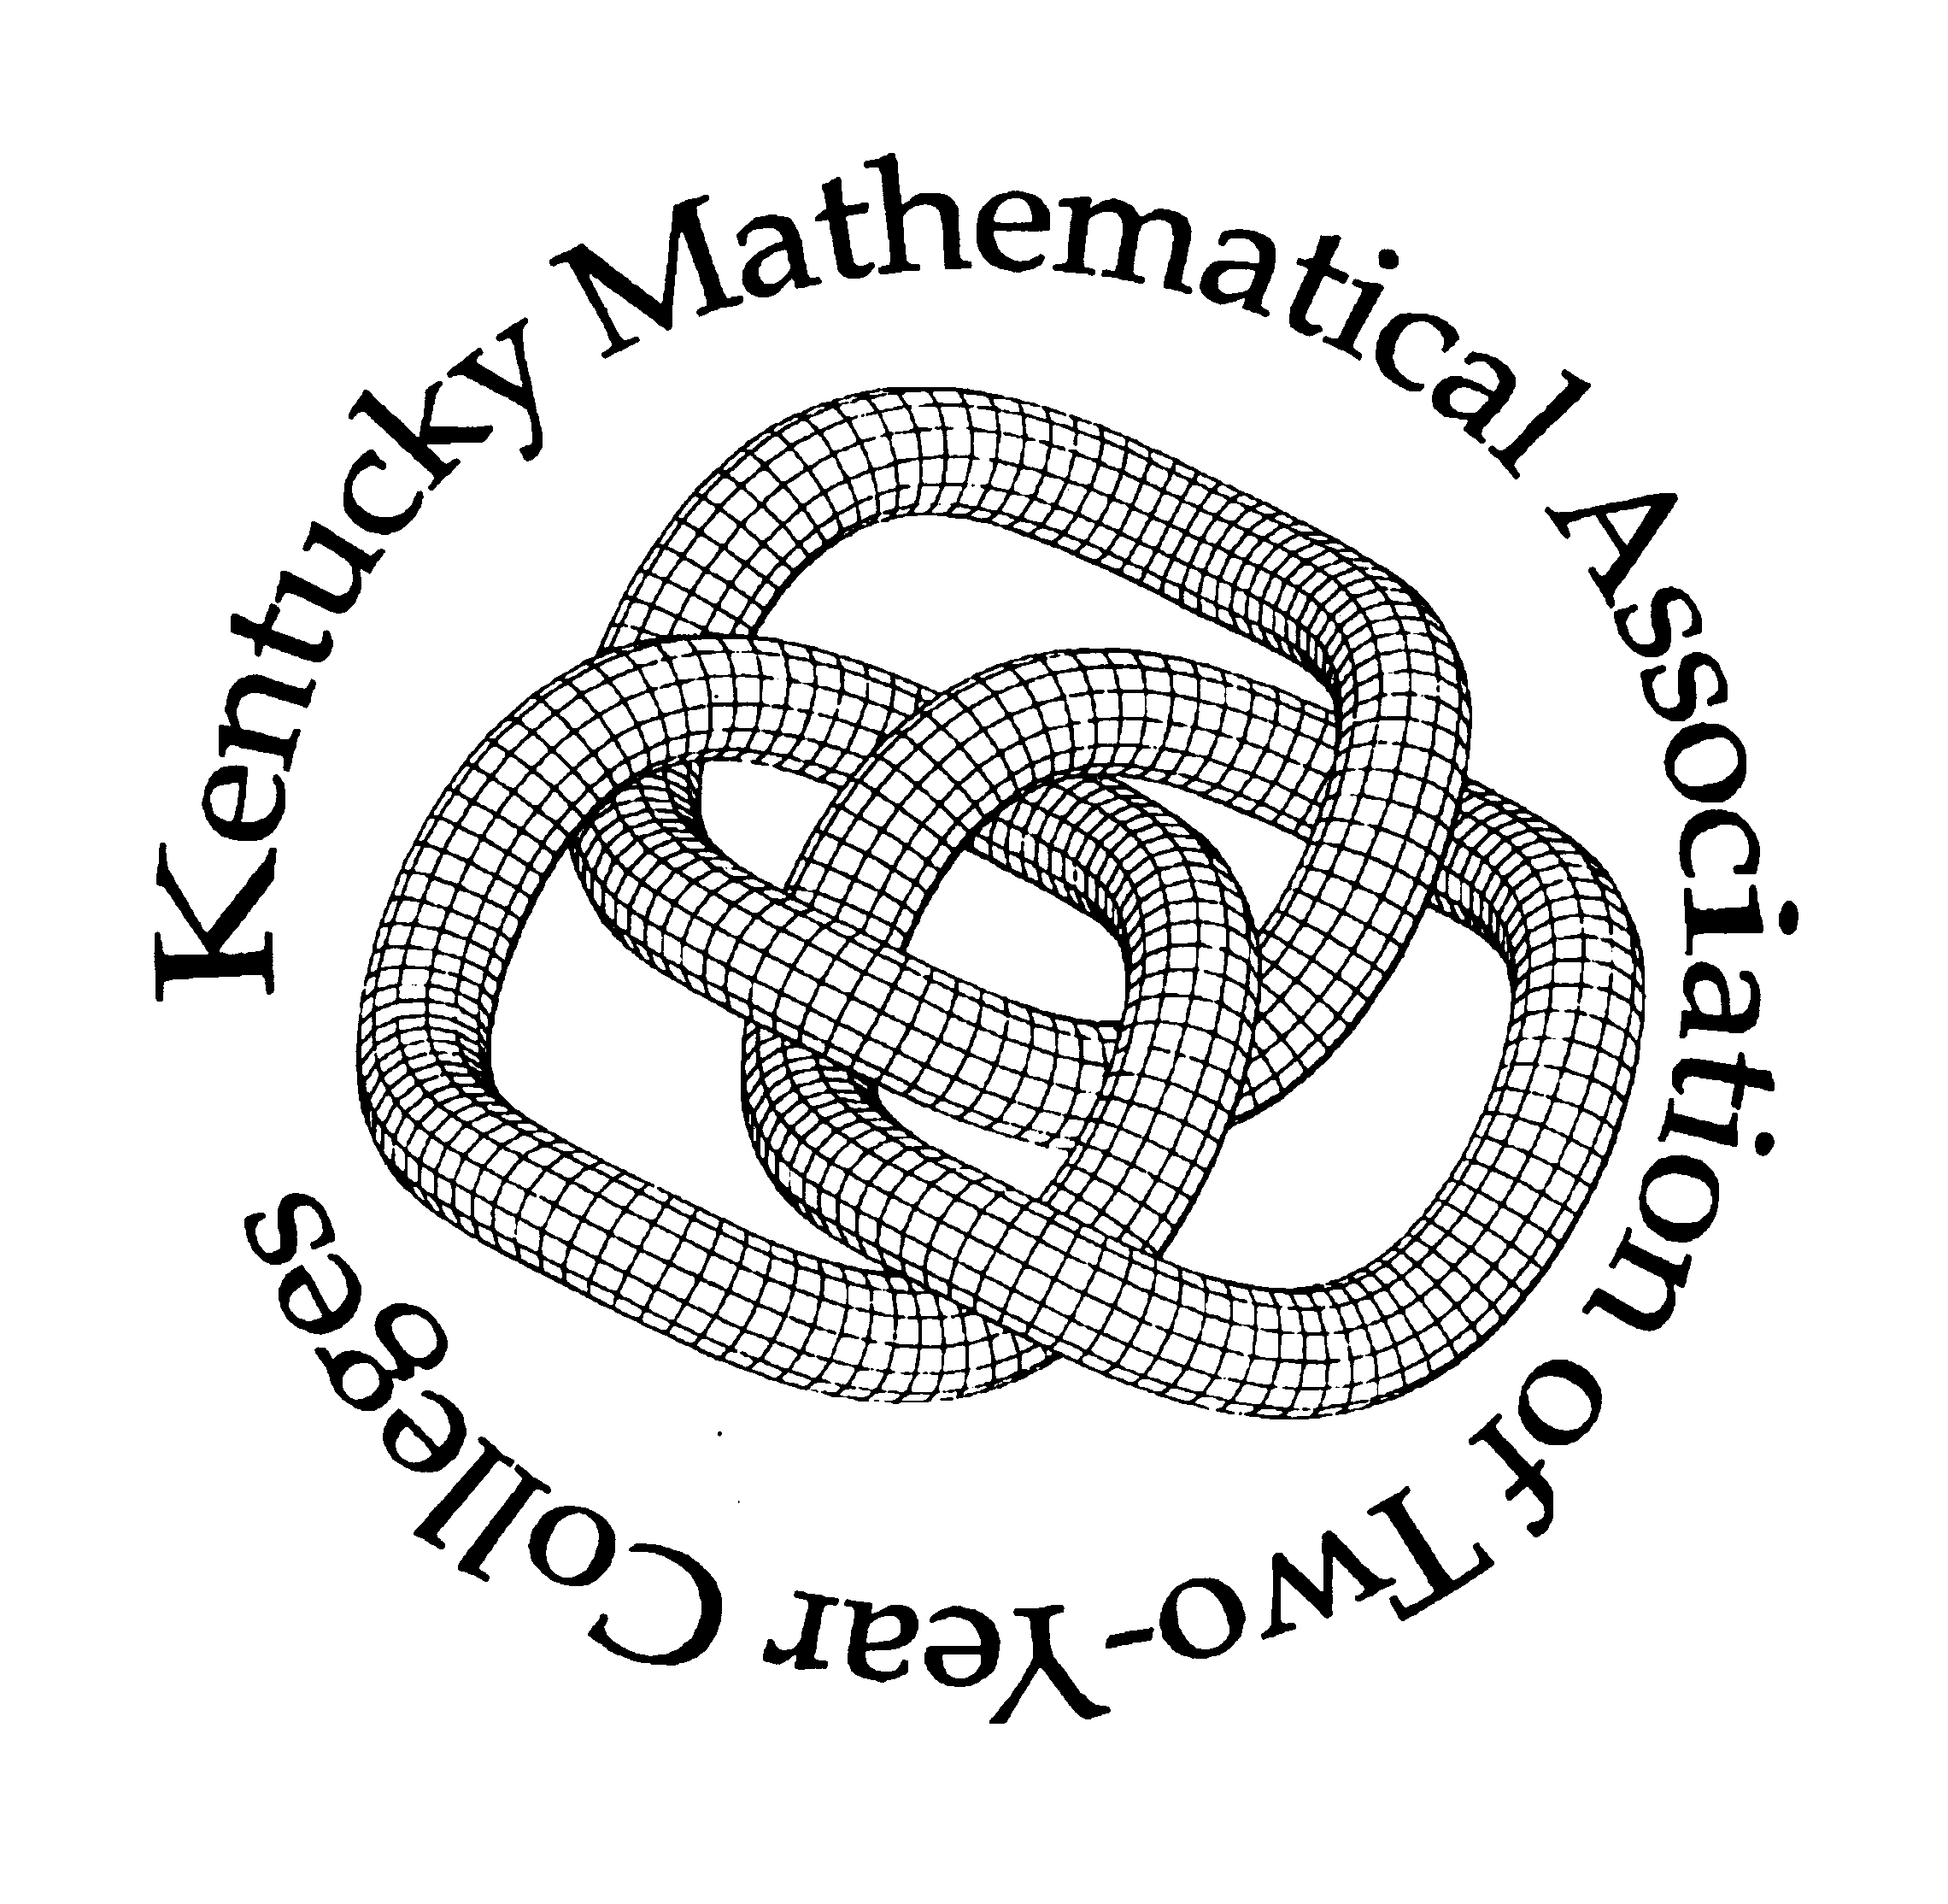

42nd Annual Meeting
Conference Center
Rough River State Resort Park
Falls Of Rough, KY
Friday, February 26th &
Saturday, February 27th, 2016
All times are local time (central time)

Forty-Second Annual Meeting of KYMATYC

Conference Agenda

Friday, February 26, 2016 All times are local time (central time)

12:00 - ?? PM Registration

1:00 -2:15 Concurrent Session #1

Grayson Room
Presenter: Angela Huddleston, Bluegrass Community and Technical College
Presider: Pat Riley, Hopkinsville Community College
How to Guide for Using MyOpenMath
MyOpenMath is a free alternative program for courses with an online component. This hands on workshop details how to use the program by looking at building a course, creating assessments, file hosting, video linking, settings, the gradebook, etc. To interact with the site on your laptop or tablet, you may request an instructor account at www.myopenmath.com prior to the workshop.

Breckinridge Room
Presenter: Tamela Randolph, Southeast Missouri State University
Presider: Scott McClendon, Somerset Community College
Co-Requisite Mathematics Courses
A discussion of how one university co-req’d their developmental mathematics (intermediate and beginning algebra) and their alternative pathway gateway courses (statistics, math for education majors, etc.) will be the focus of this presentation. Data will be presented.

2:25 – 3:15 Concurrent Session #2

Grayson Room
Presenter: Jon Oaks, Macomb Community College – AMATYC Midwest Regional Vice-President
Presider: Courtney Burch, Gateway Community and Technical College
Uses Of Bases Other Than Base 10
Most people are familiar with base 10 because it is what is used most commonly. Many people are even familiar with base 2. But what are some of the other bases used for – base 3, base 4, etc.? What about base ‘e’ or base ‘pi’? Any how about the negative bases and the hybrid bases? This presentation will cover some of the uses of all of these other bases.

Breckinridge Room
Presenter: Benjamin Aschenbrenner, Jefferson Community and Technical College
Presider: Brandon Bartley, Jefferson Community and Technical College
What the heck is math 75 anyway?
Math 75 was approved a few years ago by the system for piloting. JCTC has offered the class for two semesters. The question most often asked by students and faculty unfamiliar with the class (well, by everyone basically) is, what is math 75? In addition to talking about content choices, the presentation will go into pedagogical differences between this course and other courses and how the course at JCTC continues to evolve.

3:25-4:15 Concurrent Session #3

Grayson Room
Presenter: Kevin Kenady, Southcentral Community and Technical College
Presider: Amy Akima, Bluegrass Community and Technical College

Breckinridge Room
Presenter: Sherry McCormack, Hopkinsville Community College
Presider: Don Barnes, Hazard Community and Technical College
Contextualized and Hybridized Technical Math
Credit bearing technical math content was contextualized and hybridized using problem based learning in technical and general education programs for students unable to attend traditional classes. Hands-on applications were incorporated for increased comprehension. Discussion items will also include how to get lecture materials to students outside classroom time who are with or without internet access and ideas for hands-on activities.
(*Note: This session is from 3:25 – 3:50pm*)

4:15-4:45 Break Visit Exhibitor’s Tables and enjoy the refreshments

4:45-5:00 KYMATYC WELCOME – Door Prizes in Main Room shortly before Keynote

5:00 – 5:50 Keynote Address

Grayson Room
Presenter: Billy Hix, Motlow College Professor Emeritus
Presider: Pat Riley, Hopkinsville Community College
Math Really Rocks – a Teacher / Astronomer’s Journey
This uplifting and inspirational talk will focus on members of the mathematics and space science community who break the stereotype that many have of those in the mathematics profession. From 400 years ago and a “moose in the house” to the team members who landed a car on Mars, you will learn first hand and be able to share with your students that Math Really Rocks!

Hix is professor emeritus and is the founder and director of the Motlow College Foundation STEM Outreach program. This program provides free programs to all schools in the Motlow College service area. Since July 2015, Hix has worked with over 10,500 students and teachers. In addition, he has worked for NASA since 1997 and is a teacher liaison for the Space Foundation of Colorado. He conducts summer STEM camps to youth and teachers for the Dept. of Education in Tennessee. As a Space Foundation Liaison, Hix has traveled across the nation to speak to teachers, educational groups, and the aerospace industry about supporting STEM and methods to integrate space science into the educational curriculum. Additionally, he has been featured in a number of PBS television shows, in Astronomy and Sky’s Up magazines, and was the centerfold for the Reflector magazine in 2011. In December 2013, Hix was honored with the Master Outreach award from the American Astronomical Society. He is also serving as a science advisor to LifeWay Publishing on a new series for adults and youth that uses astronomy as a connection to religion.

If you view TV from the Nashville market, you will catch Hix along with Big Bird and friends on WNPT with his Parent Tips that support parents in the use of technology and science education.

6:00 Dinner

7:30 Ignite Session
Grayson Room
Presider: Pat Riley, Hopkinsville Community and College
Check out the ignite session. Those who did not want to present a full session but have an idea or issue they wish to share and session presenters have the opportunity to summarize their presentations. They have exactly 5 minutes in a fast paced, whirlwind, idea sharing session. This session will last as long as there are presenters.

8:00 – 8:30 STAR GAZING – NIGHT VIEWING

8:30 – 10:00 “After Math” Reception
Grayson Room
Come join us for light and lively conversation, food and drinks. Play some games, catch-up with friends, and network with colleagues and vendors.

Saturday, February 27, 2016

7:00 AM Breakfast Dining Room

8:00 – ?? Registration

8:10 – 9:00 Concurrent Session #4

Grayson Room
Presenter: Corey Wadlington, West Kentucky Community and Technical College
Presider: Scott McClendon, Somerset Community College
Spin Session
In this session, we will discuss current topics regarding mathematics in Kentucky. These topics will include the latest discussion involving assessment, developmental mathematics and transfer mathematics. Participants should come with questions, answers and an open mind.

Breckinridge Room
Presenter: Reza Akhlaghi, Big Sandy Community and Technical College
Taylor Johnson, Elizabethtown Community and Technical College
Presider: Courtney Burch, Gateway Community and Technical College
A note on Polya’s 4th Strategy – Akhlaghi
Different ways to solve some problem for our students with different level of math.
(*Note: This session will go from 8:10 – 8:35am)

Cavalieri and Archimedes – Johnson
Derive relation of volume of cylinder, Sphere, and Cone with Cavalieri Principle.
(*Note: This session will go from 8:35 – 9:00am)

Terrace Room
Presenter: Sharie Davis, Madisonville Community College
Kate Gallagher, Hawkes Learning
Presider: Brandon Bartley, Jefferson Community and Technical College
Piloting Courseware that Fits Your Classroom Culture (Commercial Presentation)
Selecting the right courseware is crucial to help students from all backgrounds succeed, so it is no easy decision! Join us to learn about one school’s choice to pilot Hawkes Learning’s courseware in its developmental math program. Associate Professor Sharie Davis from Madisonville Community College will share her experiences using Hawkes Learning in MAT 55 and MAT 65 on the Muhlenberg Campus. Topics will include course setup, implementation of the courseware, and a comparison to the previous courseware. Ms. Davis will provide the success rates from the pilot classes, feedback from students, and information on the expansion of the pilot to include all developmental math classes at the school.

Hawkes’s comprehensive learning system is built upon the principle of mastery learning to ensure that each student develops a solid foundation of the curriculum. This competency-based approach benefits students, particularly those at the margin of success. The courseware helps students affected by achievement gaps by adapting to their individual needs so that they not only pass, but understand the material and do well in future courses. A brief overview of the student courseware will be shown, followed by a discussion and Q&A session focused on attendees’ own implementation stories of technology in the classroom. Join for the chance to win a $25 Amazon gift card!

9:10 – 10:00 Concurrent Session #5

Grayson Room
Presenter: Jon Oaks, Macomb Community College – AMATYC Midwest Regional Vice-President
Presider: Don Barnes, Hazard Community and Technical College
Using Games and Technology in the Classroom
In this presentation, the speaker will discuss his use of games and technology in the classroom. Examples range from using cameras to have students conduct an on campus scavenger hunt, using iPads to enhance learning within the classroom, using buzzers to play Jeopardy-style games, and using screen-capturing software to have students send their results of online games to the instructor.

Breckinridge Room
Presenter: Edward Wicks, Elizabethtown Community and Technical College
Presider: Amy Akima, Bluegrass Community and Technical College
MyOpenMath: OER Has Arrived!
Are you looking for a new CMS? Are you interested in an innovative alternative? MyOpenMath is an open source, web-based Course Management System that exemplifies the best of what the rapidly expanding world of OER has to offer. After providing some background on this system, I will discuss the features and benefits of the program and summarize the results of its full-scale Fall 2015 implementation for MAT 65 at ECTC.

Terrace Room
Presenter: Dwight Smith, Big Sandy Community and Technical College
Presider: Pat Riley, Hopkinsville Community College
Kepler’s Laws of Motion – Sharing Session
Kepler’s Three Laws of Planetary Motion form the basis for studying celestial mechanics. They enable astronomers to calculate the orbits of comets, exoplanets, and stars in multiple star systems. I plan to hold a discussion of this topic as it relates to MAT 275 (Calculus III). Following this presentation, I will open the floor for others to share their strategies for teaching topics like this in their Calculus III classes.

10:10 - 11:00 Concurrent Session #6

Grayson Room
Presenter: Arthur Schultz, Hopkinsville Community College
Presider: Scott McClendon, Somerset Community College
How to get your students to study/review for the test
I’ve always had problems getting students to at least look at the Practice test before taking the real one, even after telling them it was a copy of the actual test. I was fed up with students asking for extra credit without even using the resources provided for them. So I decided to take care of both problems at once. In the class before the test, students separate themselves into groups of 3 or 4 and compete against the other groups in the class to see which group can score highest on the practice test, as a group. Ties are resolved by which team completed the practice test in the least amount of time.

After a 5 minute introduction (explaining the rules), those in attendance will break into one of four teams and compete for prizes.

Breckinridge Room
Presenter: Chris Heister (Cengage)
David Lally (Cengage)
Hayden Shawler (Cengage)
Presider: Courtney Burch, Gateway Community and Technical College
MindTap: Math Foundations (Commercial Presentation)
Cengage Learning’s MindTap: Math Foundations is the ONLY learning solution built specifically for and by today’s developmental studies student. Why? Because it is built -- from the ground up -- on the realities today’s developmental education students face in their daily lives of commuting and juggling conflicting priorities. MindTap: Math Foundations provides a personalized learning environment that guides students through the curriculum in a way that fits their lifestyle using the best that technology offers. Our goal is to understand students differently -- better than anyone else. Thus far we have engaged with more than 900 instructors and 350 developmental studies students. And, based on our research – they agree we are on the right track. Our goal with MindTap: Math Foundations is to solve 4 core areas of student development – Engagement, Persistence, Retention and Critical Thinking.

Terrace Room
Presenter: Scott Bain, Hopkinsville Community College
Presider: Brandon Bartley, Jefferson Community and Technical College
Eclipse Math
In 2017, a total solar eclipse will be visible in western Kentucky and many other states. I will present a number of math problems and concepts related to this eclipse which can be used in a variety of math courses. Take advantage of this opportunity to engage your students with examples that apply to this rare event.

11:00-11:15 Break Enjoy some snack food and conversation

11:15 Business Meeting with Elections Grayson Room

Kentucky Mathematical Association of Two-Year Colleges Executive Board
2014-2016

Pat Riley | President  Hopkinsville Community College
Scott McClendon | President-Elect  Somerset Community College
Linh Changaris | Secretary-Treasurer  Jefferson Community and Technical College
Brandon Bartley | Member-At-Large—Elected  Jefferson Community and Technical College
Courtney Burch | Member-At-Large—Appointed  Gateway Community and Technical College
Don Barnes | Past-President  Hazard Community and Technical College
Amanda Spencer-Barnes | Technology Officer  Hazard Community and Technical College

