Directions:
Address: 110 W Chestnut St, Louisville, KY 40202
From I-65N: Exit at Broadway, take a left (West). Turn right on 2nd Street.
From I-65S: Exit a Jefferson Street, take a left on 2nd Street.
From East or West: Take I-64 to I-65S

Parking:
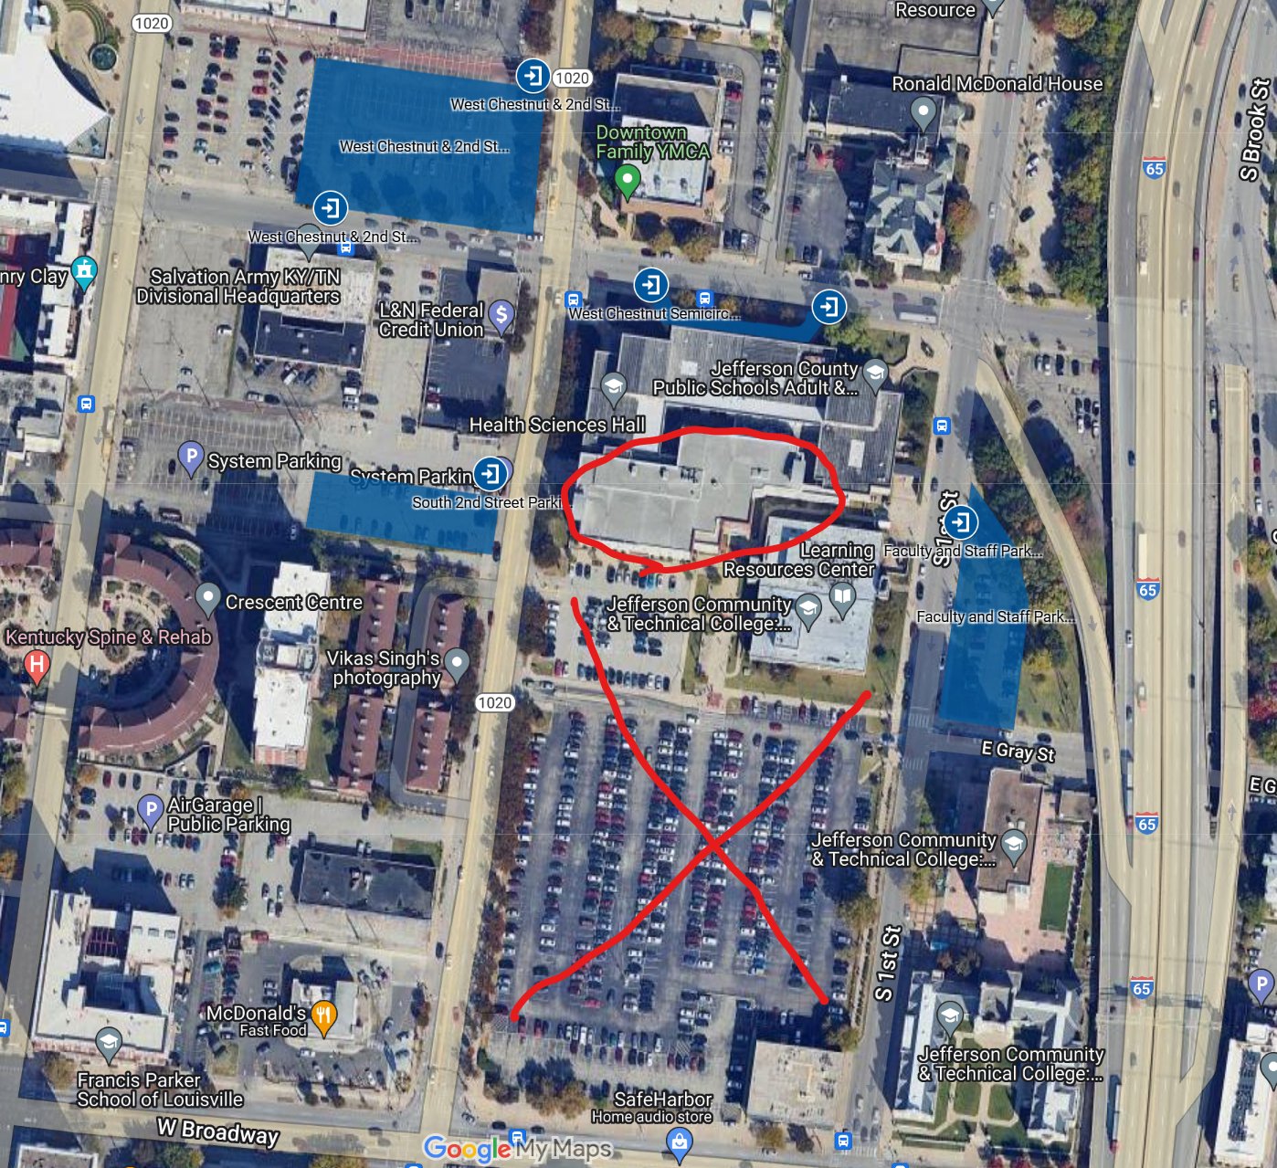

The conference is in Health Science Hall (circled in red)

Parking is available in the blue lots.
Across from Health Science Hall and across from the YMCA are your best options. Both lots are accessible from 2nd Street.

